Capstone Project Weekly Progress Report

|  |  |
| --- | --- |
| Semester | Fall 2021 |
| Course Code | AML 3406 |
| Section | Section 2 |
| Project Title | Restaurant Recommending Chatbot |
| Group Name | Group 3 |
| Student names/Student IDs | Vignesh Kumar Murugananthan C0793760 |
| Reporting Week | Week 8– 11/06/2021 |
| Faculty Supervisor | Vahid Hadavi |

# **Tasks Outlined in Previous Weekly Progress Report**

* Analyzed Business data and Review data
* Explored the data to find various insights in them by exploratory data analysis
* Grouped data based on the restaurant category and visualized them in order to understand how the data is represented.

# **Progress Made in Reporting Week**

* Firstly, we have split the train and test data sets with a composition of 80 and 20 percent respectively.
* Then we have analyzed few algorithms with our train data.
* The algorithms we used in our model building are:

Logistic regression, Decision tree classifier, KNN, Random Forest, and Gradient boost.

* After modeling we have made the confusion matrix, which is one of the important metrics in classification algorithms.

* With all the above given algorithms, we also used randomized search CV with Logistic regression to get the best parameters. With those parameters we have achieved accurate scores.

* We have developed a chatbot using micro soft azure cognitive bot service.

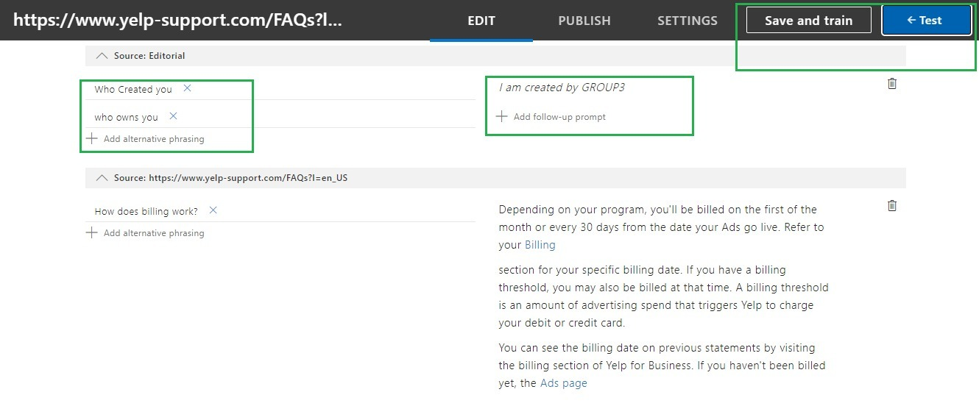

# **Difficulties Encountered in Reporting Week**

* We faced issues with SQL server database and also with Azure server which we are currently analyzing to fix it.
* We faced issues with data and the modelling takes more time for executing.
* Azure service is consuming hours , 70 percent of hours is already done.

# **Tasks to Be Completed in Next Week**

* The evaluation includes sentiment analysis like finding stop words, stemming (porter stemmer), Word tokenizing, and Visualization
* Cosine similarity
* Chatbot building

Overall Project Plan:

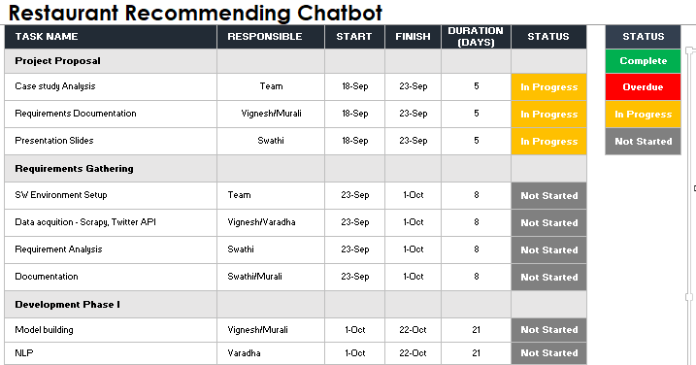

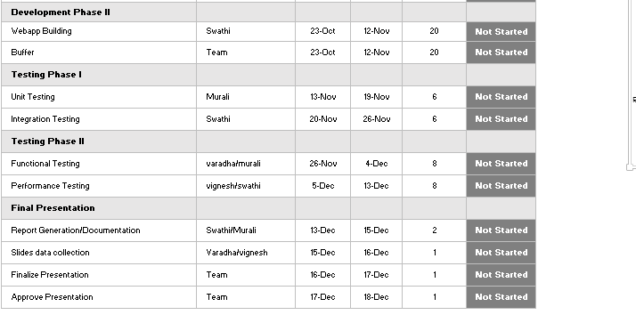

Individual Project plan:

Case study analysis

S/W environment setup

Development phase 1 – NLP

Development Phase 2 – Webapp Building

Testing Phase 2 – UNIT and Integration testing

HIGLIGHTED BELOW ARE MY RESPONSIBILITIES

